|  |
| --- |
| Web Master .inc |
| Ironman – Civil War |
| External Document |
| Version # 3.0  All Work Copyright © 2016 by Web Master .Inc.  All rights reserved. |
| Duc Minh Tran - 300771859 |
|  |

|  |
| --- |
| March 27th, 2016 |

# Table of Contents

1. Table of Contents 2

2. Version History 3

3. Game Description 4

4. Controls 4

5. Interface Sketch 4

6. Screen Descriptions 7

7. Character 12

8. Enemies 13

9. Scoring 14

10. Sound Index 14

11. Art/ Multimedia Index 15

# Version History

* Version 1.0 Main Core Finished (March 22, 2016)
  + Player can control Iron man
  + Health and Shield fly around randomly
  + Collisions appeared as console log
* Version 2.0 Game Mechanic Finished (March 25, 2016)
  + Ironman animations added – Interact with collisions
  + Left Click for shooting, bullets make shields bounce around randomly
  + Score and Health added
  + Ironman can die
* Version 3.0 Game Completed (March 27, 2016)
  + Sound effects added
  + Bugs Fixed
  + Ironman can win when he reaches certain score

# Game Description

This is a side scrolled game that is inspired from the movie Captain America: Civil War

In order to play the game, player will control Ironman and make him move up or down to avoid Captain America Shields. Whenever Ironman is not getting hit, he gets his point increased. However, if he get hit by the shields, he will lose both his point and health. Health can be gained back by collecting ARC Reactor on the way

When the health drop below 0, Ironman will die and player will be directed to the losing scene after 4 seconds

When the point reached over 5000, Ironman win and player will be directed to the wining scene after 3 seconds

# Controls

Player control Ironman and make him fly up and down using mouse. Left and Right movement is restricted.

Player can press left button to make Ironman shoots

# Interface Sketch

Menu Screen

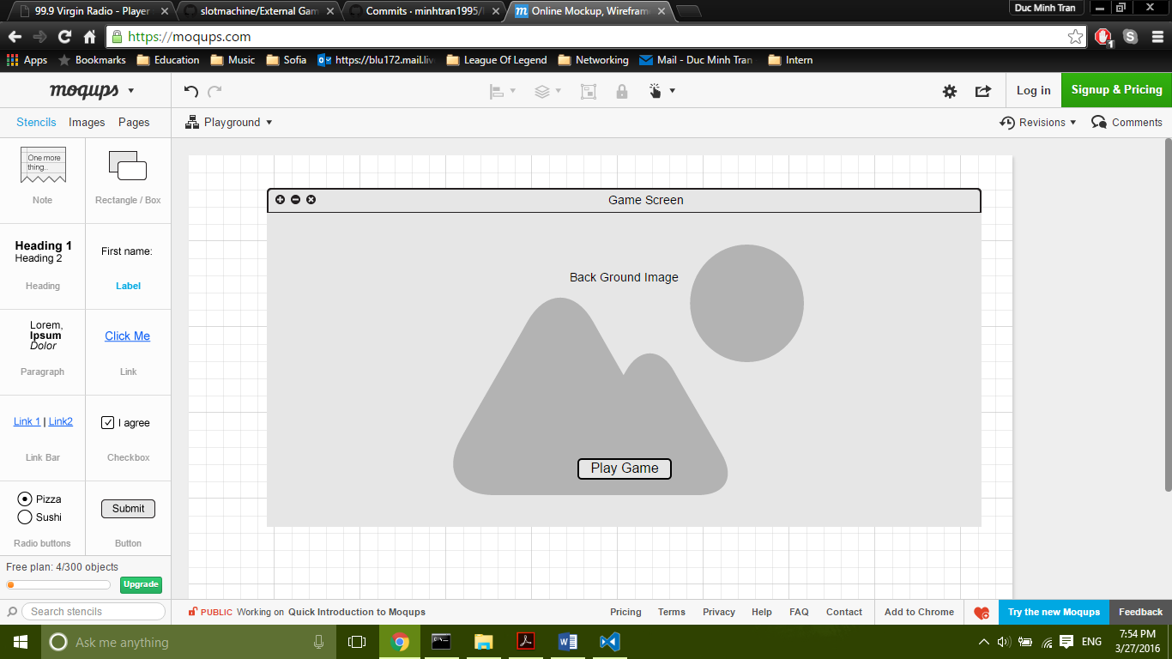

Instruction Screen

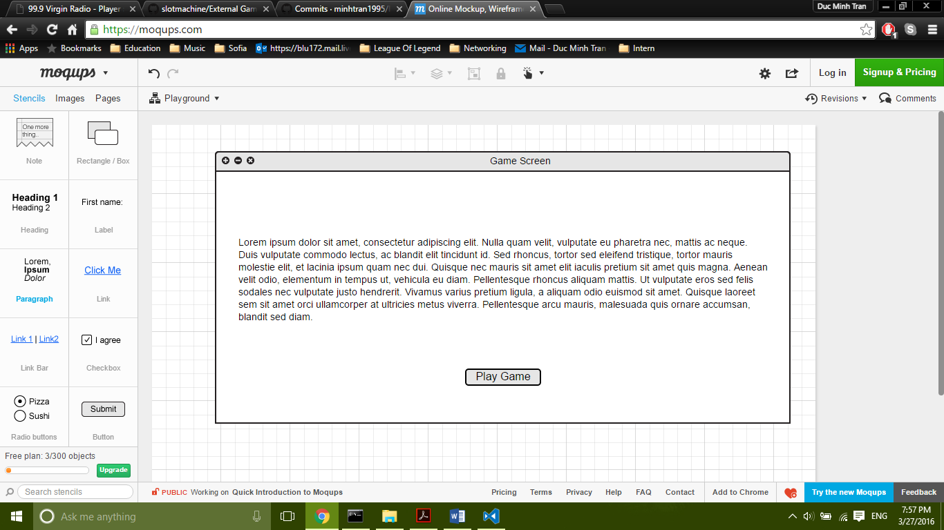

Game Screen

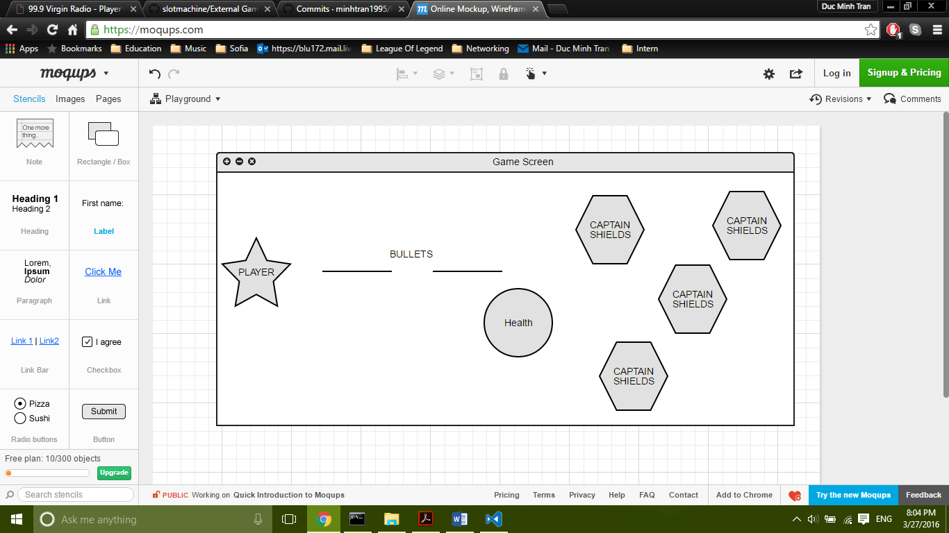

Wining/Losing Scene

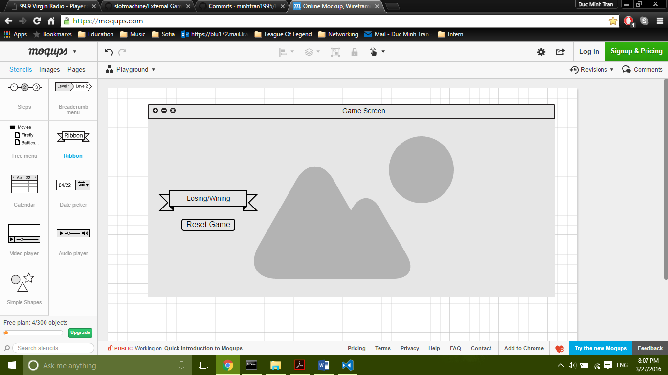

# Screen Descriptions

Menu Screen

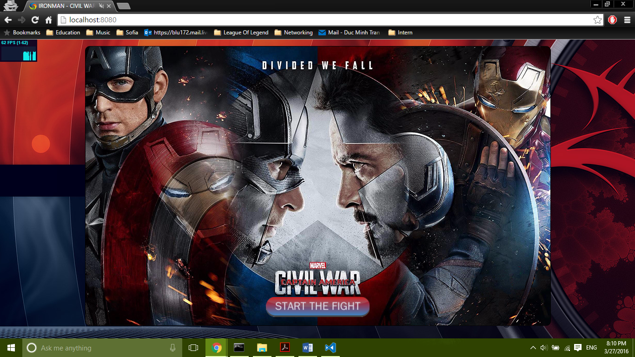

Instruction Screen

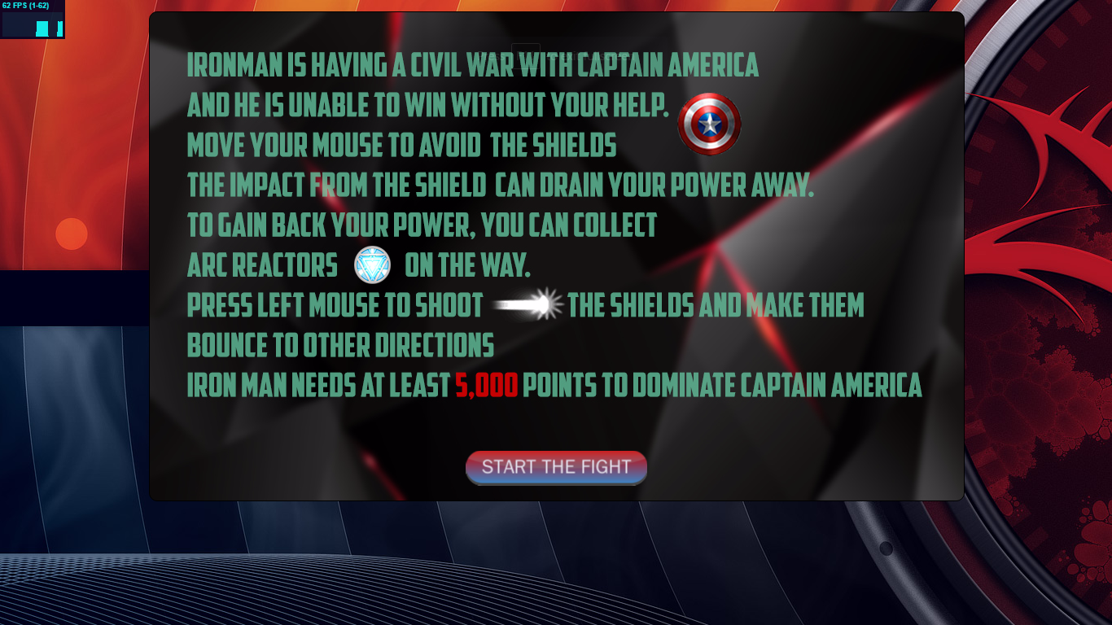

Play Screen

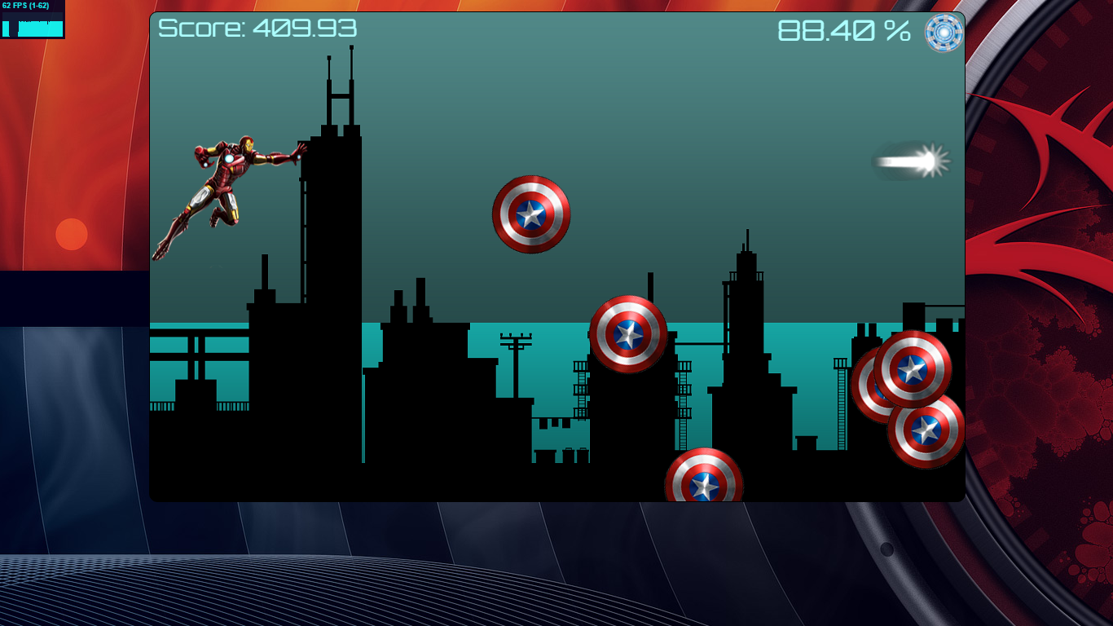

Lose Screen

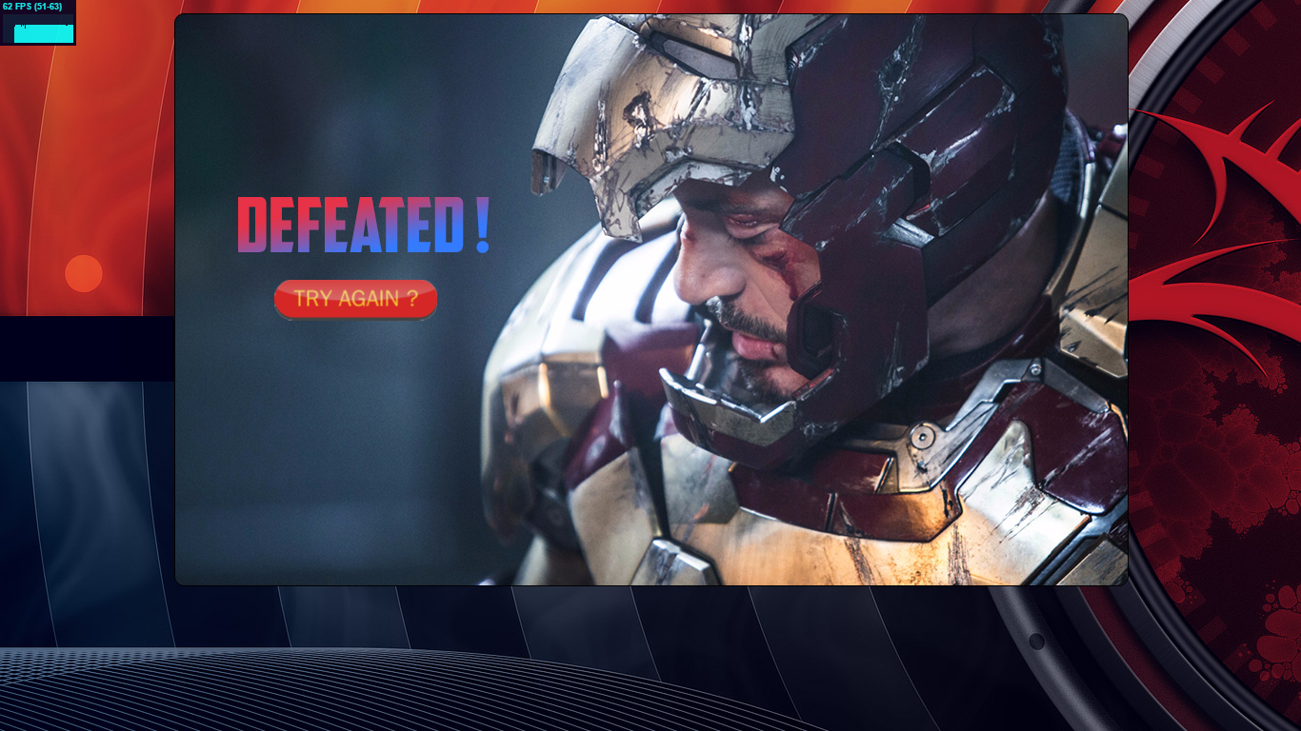

Win Screen

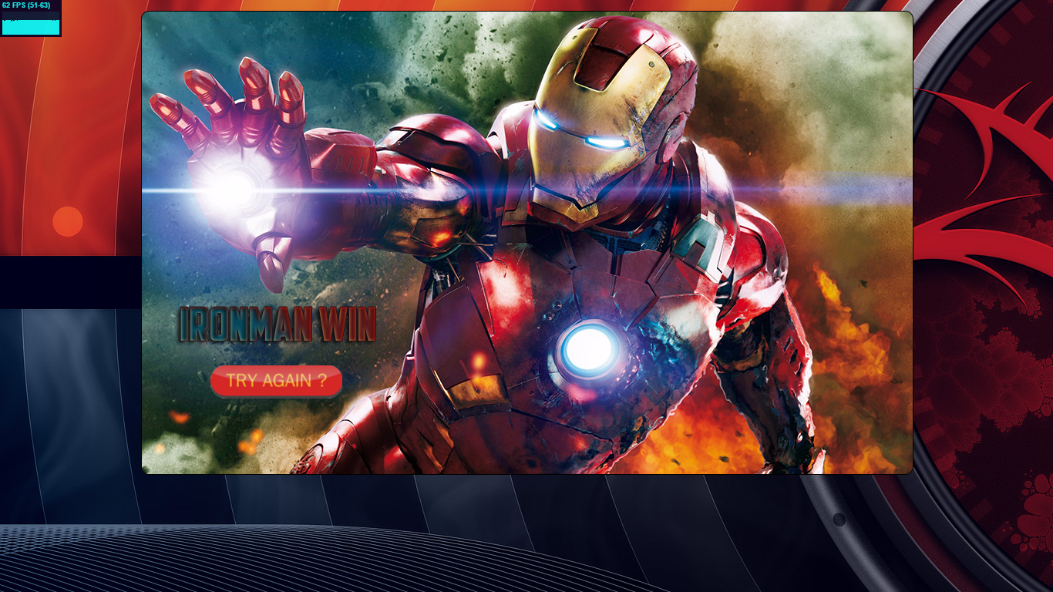

# Character

Player will control Ironman, as he is flying to the right hand side

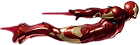

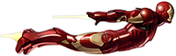

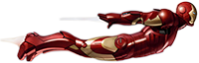

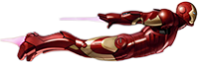

On left click, he will shoot

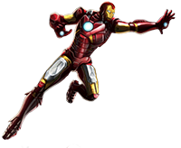

When on collision, Ironman will display these images

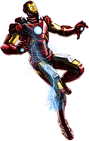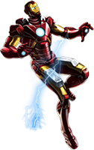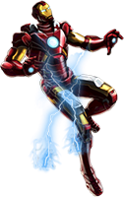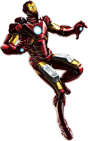

When collect health, Ironman will display these images



When Ironman have no power left, he will be torn apart

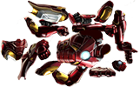

# Enemies

Enemies will be all the shields thrown by Captain America, they will be flying around randomly with unexpected speed and directions.

When player shoot the shields, they will increase the flying speed and bounce in a different direction

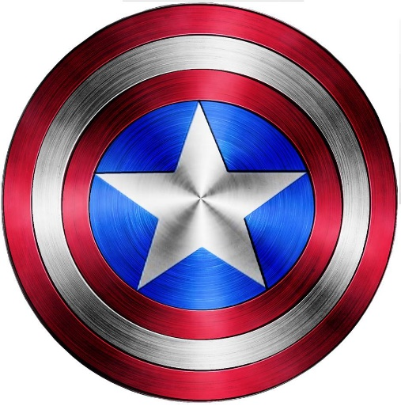

# Scoring

Every time player is not hit by the shield, his score will be increased by 1. If he collide with the shield, his score will decrease by 1 and health is decreased by 0.1 (base on how long the impact is)

When player shoot the shield, his score will be increased by 10.

When player collect health, his score will increase by 1 and health will be increased by 0.5 (based on how long the impact is)

# Sound Index

**Sound Clips**

Bmg.mp3

leftClick.mp3

shoot.mp3

Heal.mp3

Ricochet.mp3

Shocked.mp3

# Art/ Multimedia Index

